**WEEK 5: Assignment**

1. How many regions are there for the following graph? What the degree of each region?

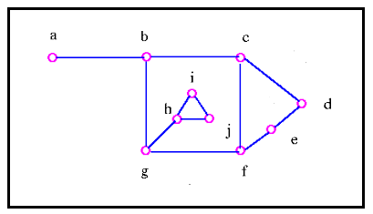

Answer: There are 4 regions in the following graph as shown in the answer graph. The degree for:

Region 1: h-i-j so, degree 3

Region 2 :h-g-b-c-f-g-h-j-i-h so; degree :9

Region 3:c-d-e-f so; degree 4

Region 4: degree :7

Number of regions in the graph:

R=e-v+2

R=12-10+2

R=4

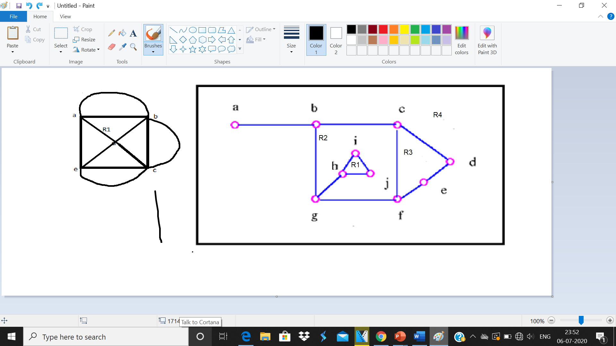

1. How many more edges are required to make the following graph a maximum planar graph? Justify your answer.

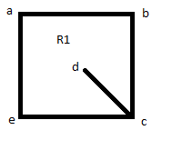

Answer: We will require 4 more edges to make it maximum planar graph. A plane graph is called as maximum plane graph if you can add edges to the graph maintaining its property of being planar. So we can just join the vertices b and d , e and d and e and b and a and d to get a maximum planar graph.

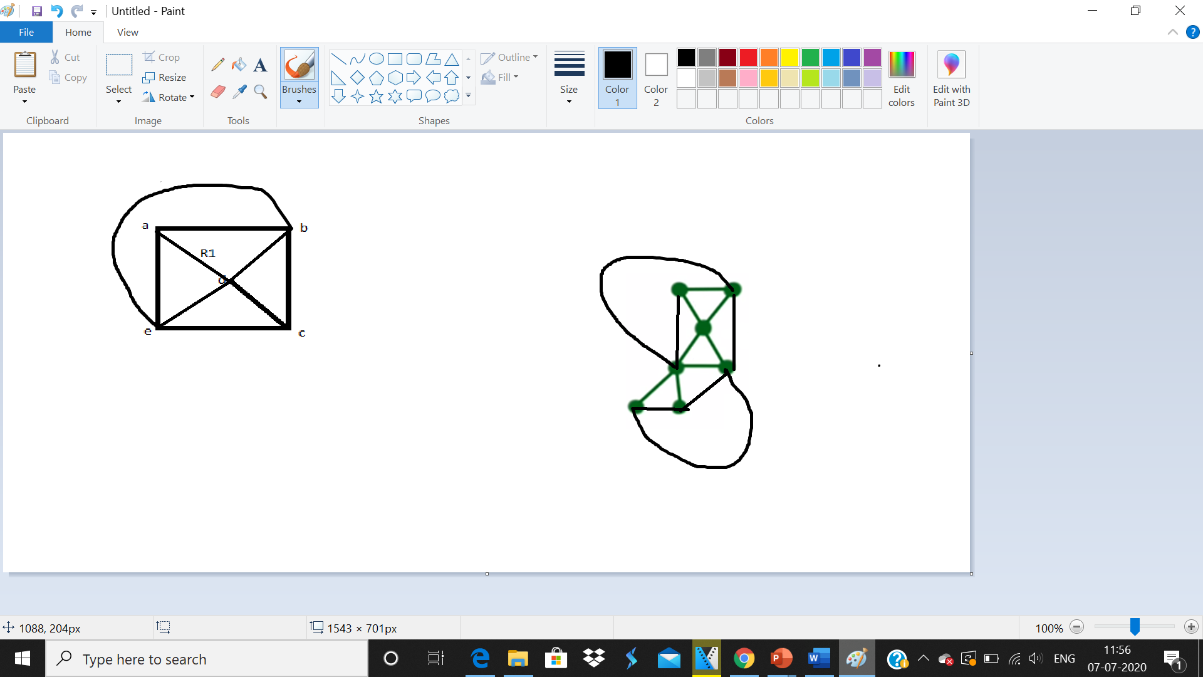

1. How many possible regions can be obtained if the following graph is drawn as maximal plane graph? Justify your answer.

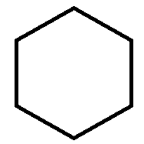

‘A’

Answer: A plane graph is called as maximal plane graph if you can add edges to the graph ‘A’ maintaining its property of being planar. The boundary of all the regions in the Graph ‘A’ below has a triangle, thus this property is also called as Triangulation.Similarly, the maximum planar graph of the following hexagon can be obtained by adding six edges to the graph maintaining the planarity of it. There are 8 regions - 7 bounded region and 1 exterior region, which are all triangle. Thus, follow the property of Triangulation.

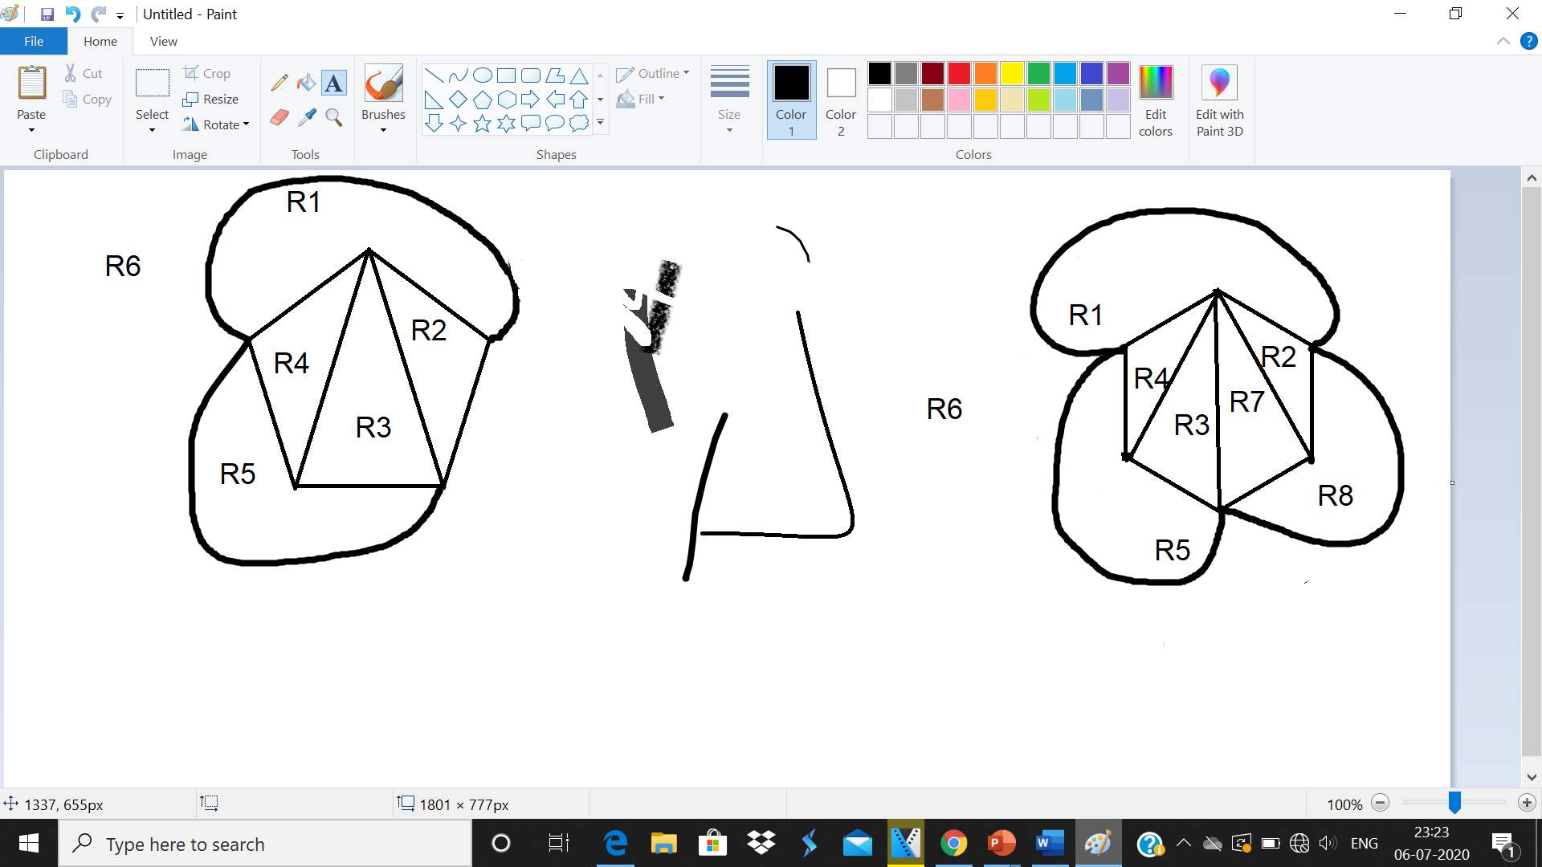

1. What will the number of regions if the following graph is a maximal planar graph?



Answer:

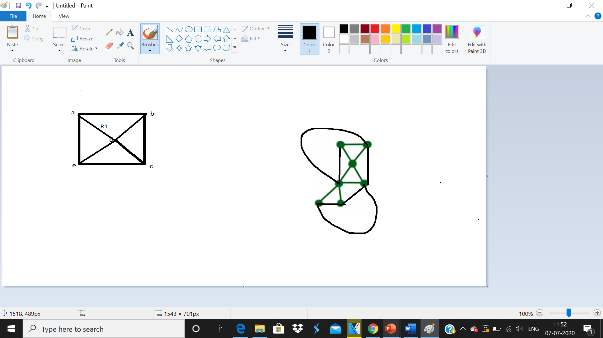

1. Which of the following statements are false for the following graph? Justify your answer with appropriate definitions.



Statement 1: The graph is a complete graph.

Answer: True, it is a complete graph with K2 .i.e. 2 vertices. A complete graph is nothing but every node should be connected to all other node ; in a complete graph every node is adjacent to all other nodes in graph.

Statement 2: The graph is a complete bipartite graph.

Answer: True, bipartite graph is a graph in which a set of graph vertices can be divided into two independent sets, and no two graph vertices within the same set are adjacent.

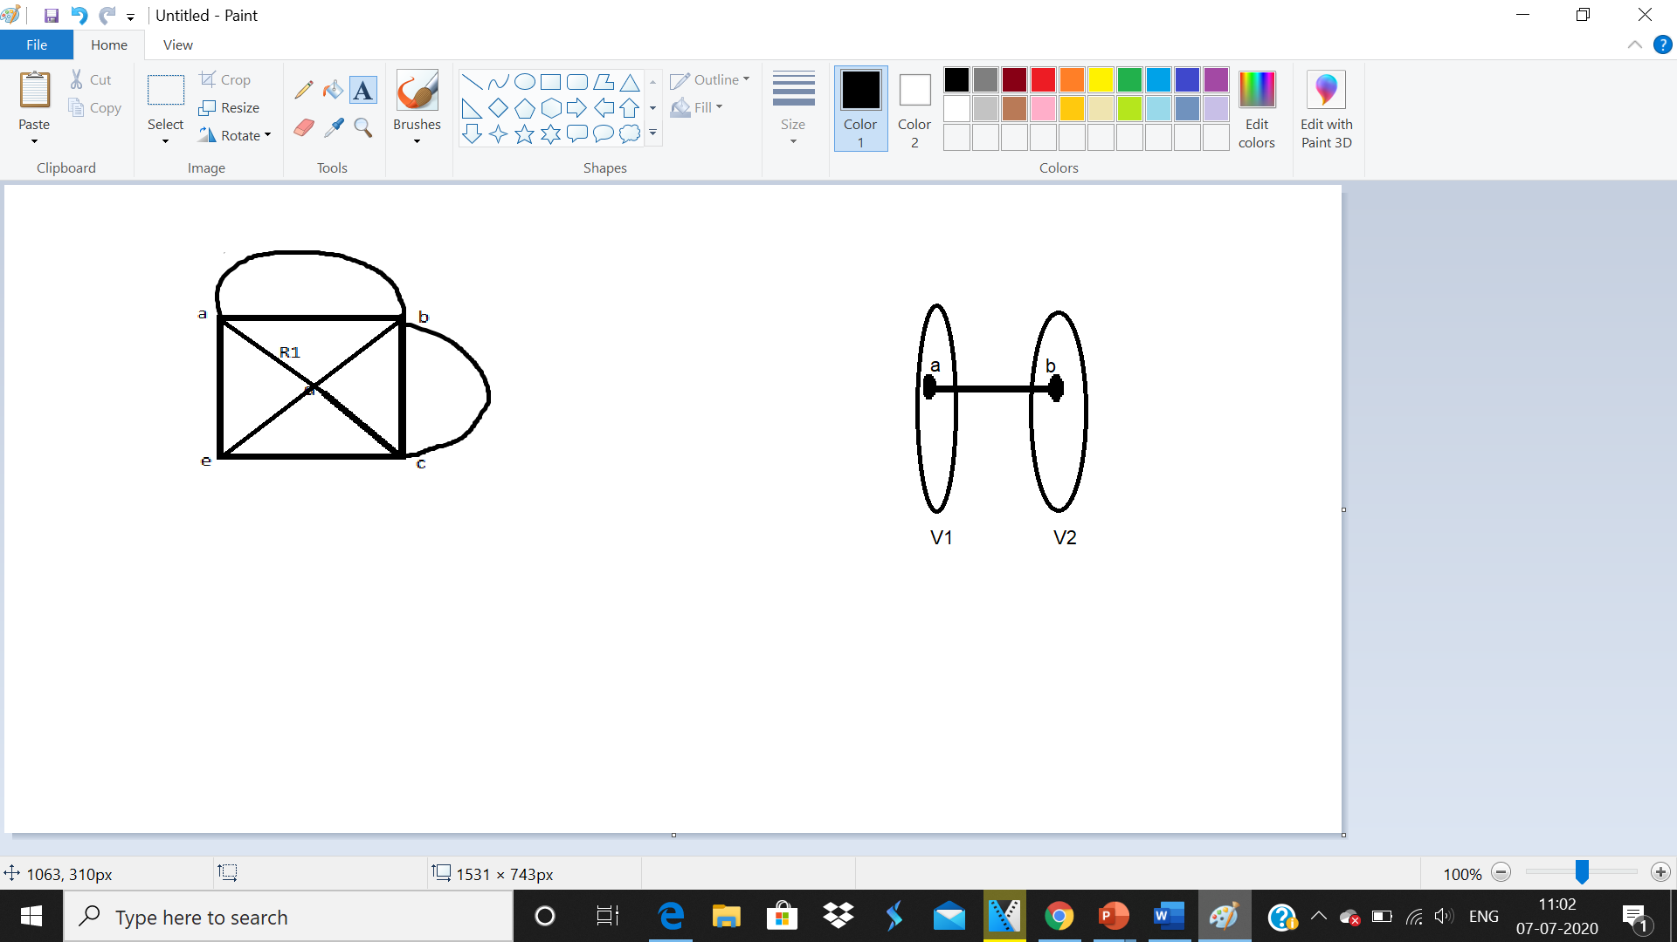

Statement 3: The graph is not a bipartite graph.

Answer: False.

Statement 4: The graph is a connected graph.

Answer: True. Here is a path from any point to any other point in the **graph which is connected.** A **graph** that is not **connected** is said to be disconnected.